# Exercise Sheet 5: Euro Drives or Patios

You work as a programmer for a local software company. A local building company ‘MyDrive’, who specialise in laying patios and driveways in both the UK and France, has asked your employer to create a simple desktop application that can be used to give quick quotations when responding to telephone enquiries.

The program will be left running during the working day, but because of the fluctuating price of materials and the exchange rate between UK Pounds/Euro they need to input the cost of material values daily.

Your employer and the design team have interviewed the client and have agreed the user interface for this program. The program does not have to be executed as ‘full screen’ but should be proportional and centralised within the screen area.

The cost of providing extra deep foundations = Standard cost + 25%

The following example values have been supplied to further assist you: -

Exchange rate for GB Pounds to Euros £ 1 = €1.45

Materials per square metre Brick = £ 35.75

Concrete = £ 25.50

Tarmac = £ 20.00

Gravel = £ 29.75

Note: There is no need to calculate local taxes (e.g. VAT) as they will be shown on a separate invoice and are allowed for in the prices shown above.

Your employer has given you the task of creating the program in C# which must conform to the agreed specification (see example screen prints below) and test the program prior to its final implementation.

## Outline specification agreed with the client.

### Fig 1

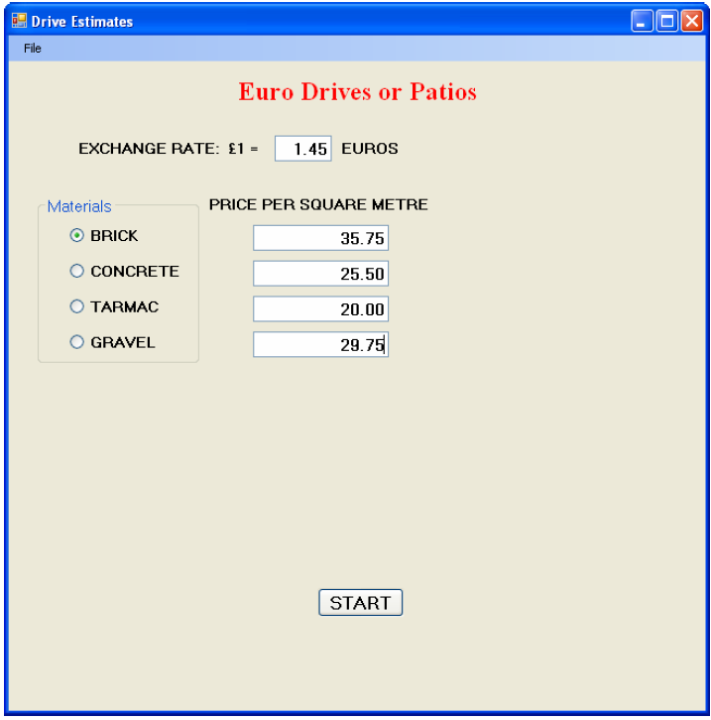

On execution Fig 1 is to be displayed to enable input of the day’s exchange rate and material costs per square metre. At this stage the form heading ‘Euro Drives or Patios’ text colour must be set to red.

### Fig 2

Clicking the ‘START’ button without an entry in any one of the text boxes must result in a message box being displayed similar to Fig 2.

### Fig 3

Clicking the ‘START’ button with entries in all text boxes must result in the input boxes being hidden from view and the display of further option buttons, text boxes, buttons and label as shown in Fig 3. In addition, the label above the buttons must become visible and both the label and the form heading text changed to green.

### Fig 4

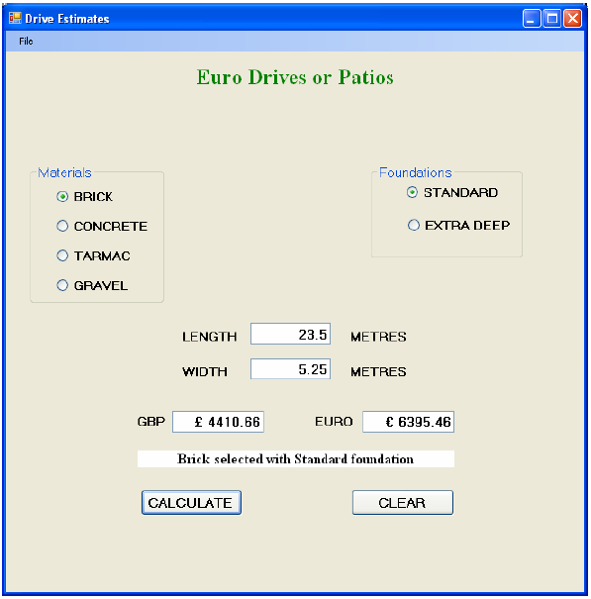

Selection of the type of material and the required foundations, along with the length and width shall result in a calculated value in GB Pounds when the ‘CALCULATE’ button is clicked. That value must be converted to Euros and displayed in the Euro text box. As a further safeguard, the label above the buttons must change to a white background with text confirming the options selected on the form.

### Fig 5

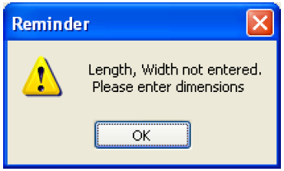

On clicking ‘CALCULATE’, if there is no entry for either the length or width then the screen shall revert to that shown in Fig 3 awaiting new selections and dimensions.

### Fig 6

Clicking the ‘CLEAR’ button shall clear all text boxes and await input as shown in Fig 3.

### Fig 7

Clicking the menu option File|Exit shall cause a message box to appear similar to above. Selection of ‘Yes’ shall cause the application to terminate and ‘No’ to continue with the program in its existing state.

## Detail

1. The project is to be saved as MyDrive and the main form saved as frmEstimate.
2. Public variables may be used, but as far as possible local variables must be declared.
3. frmEstimate to be created similar to that shown in figs 1, 3, 4 and 6. At design the following properties are to be set to:

StartPosition: CenterScreen

Text: Drive Estimates

WindowState: Normal

1. The title ‘Euro Drives or Patios’ must be set at design to:

Font Name: Times New Roman

Font Style: Bold

Font size: 18pt

ForeColor: Red

1. Create two GroupBox controls named grpType and grpFoundations.
2. grpType to contain four radio buttons to select from Brick, Concrete, Tarmac or Gravel. The material type is to be used for the labels. The text property for grpType is to be set to ‘Materials’.
3. grpFoundations to contain two radio buttons for Standard and Extra Deep foundations. The foundation type is to be used for the labels and grpFoundations text property set to ‘Foundations’.
4. Using Fig 1 and Fig 3 as a guide create the remaining labels, text boxes and buttons (ie 9 Text boxes, 9 Labels and 3 Buttons). The three button names and text properties must be set at design to:

|  |  |  |  |
| --- | --- | --- | --- |
| Name | cmdStart | cmdCalculate | cmdClear |
| Text | START | CALCULATE | CLEAR |

1. Text boxes are to be set to right aligned text with empty text boxes.
2. Add a menu strip to the form with one menu item named ‘File’ and one drop down item named ‘Exit’.
3. The label located between the currency rates and the CALCULATE and CLEAR buttons must to be set at design to:

Name: lblOutput

Font Name: Times New Roman

Font Style: Bold

Font Size: 12pt

TextAlign: MiddleCentre

1. Write code that, when the program is executed, produces a form similar to that shown in Fig 1. Note: Only those labels, text boxes, grpType and cmdStart as shown in Fig 1are to be visible.
2. Clicking the ‘START’ button when any one of the five text boxes is empty shall result in an error message being displayed similar to that shown in Fig 2. The message box must display an OK button and an exclamation mark icon.
3. After clicking the ‘START’ button :–

* All five text boxes, their respective labels and the ‘START’ button itself should no longer be visible.
* From Fig 1, only the group box grpType and the form title shall remain displayed.
* The remaining text boxes, their labels, grpFoundations, lblOutput and the command buttons must become visible as shown in Fig 3.
* The form title ‘Euro Drives or Patios’ must have its text colour changed to green.
* The label lblOutput must have no text displayed and its background colour changed to green.
* The text box showing GB Pounds must display the number 1
* The text box used for Euros must show the current exchange rate (1.45)

1. The program must allow the user to enter the size of the drive or patio in metres (length and width), select the type of material required (brick, concrete, tarmac or gravel) and the depth of foundations (standard or extra deep).
2. Clicking the ‘CALCULATE’ button must cause a check to be made that both the length and width entries have been completed. If one or more is empty then a message must be displayed similar to that at Fig 5. The message box must display an OK button and an exclamation mark.
3. If there are values in the length and width text boxes then the cost of the job must be calculated based on the daily values entered for materials and exchange rates. The result must be calculated in GB Pounds then converted to Euros and the values replace those currently displayed in their respective text boxes. These values must be rounded to two decimal places as shown in Fig 4, along with their currency indicators (ie £3.40, €4.93).
4. The label lblOutput must have its background colour changed to white and display details of the type of finish and selected foundations similar to that shown in Fig 4.
5. Clicking the ‘CLEAR’ button must clear the values in the calculated text boxes and display the form’s content as shown in Fig 3 awaiting entry.
6. Selection of the menu option File|Exit must cause a message box to appear with Yes/No and a question mark icon similar to Fig 7.
7. Selection of ‘Yes’ must cause the application to terminate while selection of ‘No’ shall allow the application to continue in its current mode.